**SUPERSET ID: 6408269**

**TOPIC : REACT**

**EXERCISE : 9. REACT JS-HOL**

In command prompt,

cd Desktop

npx create-react-app cricketapp1

cd cricketapp1

code .

**In visual studio code,**

**ListofPlayers.js**

import React from 'react';

const ListofPlayers = ({ players }) => {

return (

<ul>

{players.map((p, i) => (

<li key={i}>{p.name} - {p.score}</li>

))}

</ul>

);

};

export default ListofPlayers;

**Scorebelow70.js**

import React from 'react';

const Scorebelow70 = ({ players }) => {

const filtered = players.filter(p => p.score < 70);

return (

<ul>

{filtered.map((p, i) => (

<li key={i}>{p.name} - {p.score}</li>

))}

</ul>

);

};

export default Scorebelow70;

**OddPlayers.js**

function OddPlayers({ IndianTeam }) {

return (

<div>

{IndianTeam.odd.map((player, index) => (

<p key={index}>

{index === 0 && "First"}{index === 1 && "Third"}{index === 2 && "Fifth"} : {player}

</p>

))}

</div>

);

}

export default OddPlayers;

**EvenPlayers.js**

function EvenPlayers({ IndianTeam }) {

return (

<div>

{IndianTeam.even.map((player, index) => (

<p key={index}>

{index === 0 && "Second"}{index === 1 && "Fourth"}{index === 2 && "Sixth"} : {player}

</p>

))}

</div>

);

}

export default EvenPlayers;

**ListofIndianPlayers.js**

function ListofIndianPlayers({ IndianPlayers }) {

const merged = [...IndianPlayers.T20, ...IndianPlayers.Ranji];

return (

<ul>

{merged.map((player, index) => (

<li key={index}>{player}</li>

))}

</ul>

);

}

export default ListofIndianPlayers;

**App.js(when flag =true)**

import React from ‘react’;

import ListofPlayers from ‘./ListofPlayers’;

import Scorebelow70 from ‘./Scorebelow70’;

import OddPlayers from ‘./OddPlayers’;

import EvenPlayers from ‘./EvenPlayers’;

import ListofIndianPlayers from ‘./ListofIndianPlayers’;

function App() {

const flag = true;

const players = [

{ name: “Sachin1”, score: 85 },

{ name: “Dhoni2”, score: 92 },

{ name: “Virat3”, score: 67 },

{ name: “Rohit4”, score: 74 },

{ name: “Yuvraj5”, score: 58 },

{ name: “Raina6”, score: 77 }

];

const IndianTeam = {

odd: [“Sachin1”, “Virat3”, “Yuvraj5”],

even: [“Dhoni2”, “Rohit4”, “Raina6”]

};

const IndianPlayers = {

T20: [“Mr. First Player”, “Mr. Second Player”, “Mr. Third Player”],

Ranji: [“Mr. Fourth Player”, “Mr. Fifth Player”, “Mr. Sixth Player”]

};

if (flag === true) {

return (

<div>

<h1>List of Players</h1>

<ListofPlayers players={players} />

<hr />

<h1>List of Players having Scores Less than 70</h1>

<Scorebelow70 players={players} />

</div>

);

} else {

return (

<div>

<div>

<h1>Indian Team</h1>

<h2>Odd Players</h2>

<OddPlayers IndianTeam={IndianTeam} />

<hr />

<h2>Even Players</h2>

<EvenPlayers IndianTeam={IndianTeam} />

</div>

<hr />

<div>

<h2>List of Indian Players Merged:</h2>

<ListofIndianPlayers IndianPlayers={IndianPlayers} />

</div>

</div>

);

}

}

export default App;

**OUTPUT SCREENSHOT (when flag=true)**

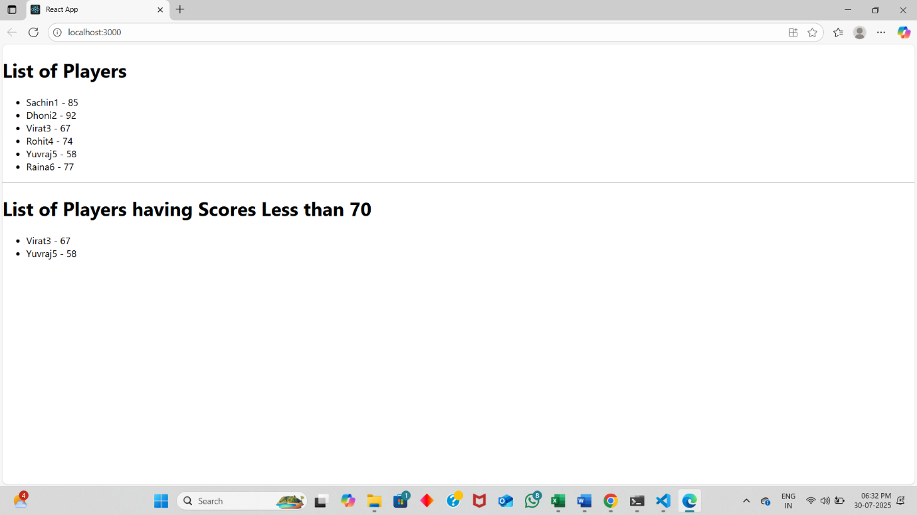

**App.js (when flag=false):**

import React from 'react';

import ListofPlayers from './ListofPlayers';

import Scorebelow70 from './Scorebelow70';

import OddPlayers from './OddPlayers';

import EvenPlayers from './EvenPlayers';

import ListofIndianPlayers from './ListofIndianPlayers';

function App() {

const flag = false;

const players = [

{ name: "Sachin1", score: 85 },

{ name: "Dhoni2", score: 92 },

{ name: "Virat3", score: 67 },

{ name: "Rohit4", score: 74 },

{ name: "Yuvraj5", score: 58 },

{ name: "Raina6", score: 77 }

];

const IndianTeam = {

odd: ["Sachin1", "Virat3", "Yuvraj5"],

even: ["Dhoni2", "Rohit4", "Raina6"]

};

const IndianPlayers = {

T20: ["Mr. First Player", "Mr. Second Player", "Mr. Third Player"],

Ranji: ["Mr. Fourth Player", "Mr. Fifth Player", "Mr. Sixth Player"]

};

if (flag === true) {

return (

<div>

<h1>List of Players</h1>

<ListofPlayers players={players} />

<hr />

<h1>List of Players having Scores Less than 70</h1>

<Scorebelow70 players={players} />

</div>

);

} else {

return (

<div>

<div>

<h1>Indian Team</h1>

<h2>Odd Players</h2>

<OddPlayers IndianTeam={IndianTeam} />

<hr />

<h2>Even Players</h2>

<EvenPlayers IndianTeam={IndianTeam} />

</div>

<hr />

<div>

<h2>List of Indian Players Merged:</h2>

<ListofIndianPlayers IndianPlayers={IndianPlayers} />

</div>

</div>

);

}

}

export default App;

**OUTPUT SCREENSHOT (when flag=false)**

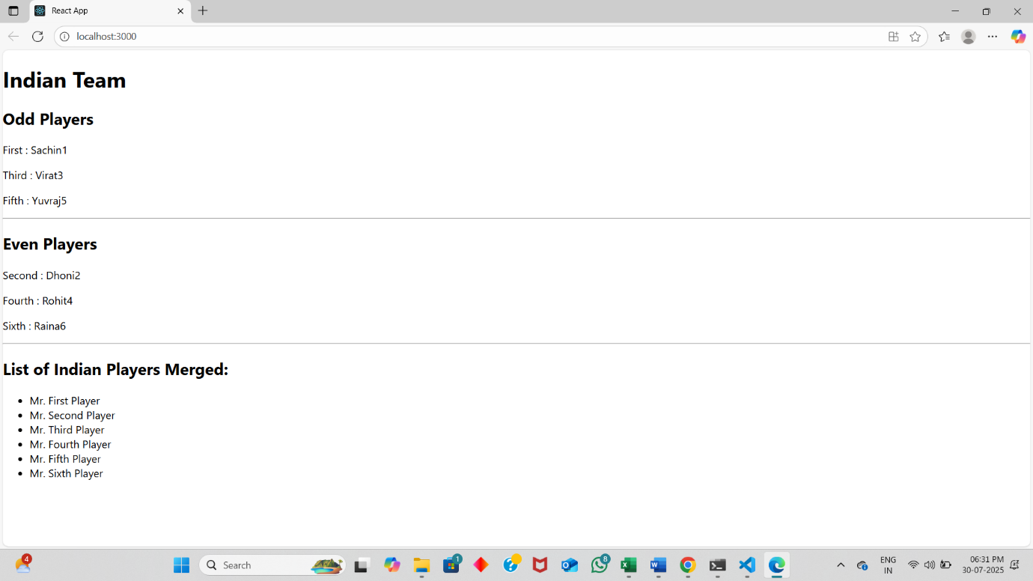

To run,

In cmd

npm start